

**The University of Azad Jammu and Kashmir,**

**Muzaffarabad**

|  |  |
| --- | --- |
| Name | Kamal Ali Akmal |
| Course Name | Computer Architecture and Logic Design |
| Submitted to | Engr. Sidra Rafique |
| Semester | 2nd |
| Session | 2024-2028 |
| Roll No | 2024-SE-38 |
| Lab No | 06 |
| Submission date | 19 August 2025 |

**Encoders & Decoders**

**Encoder**

* An **encoder** is a device or circuit that **converts information from one form to another (usually into a coded form).**
* It takes **2ⁿ input lines** and gives an **n-bit binary output**.
* Example:
  + A **decimal-to-binary encoder** converts decimal input (like 0–9) into binary code.
  + If you press key “5” on a keypad, the encoder outputs 0101 (binary for 5).

**Purpose**: Reduce many input lines into fewer coded output lines.

*Example:* ***8-to-3 Encoder***

*Keyboard key pressed → binary code sent to computer.*

**Truth Table:**

| **D7 D6 D5 D4 D3 D2 D1 D0** |  |  |  | **C B A** |  |
| --- | --- | --- | --- | --- | --- |
| 0 0 0 0 0 0 0 **1** |  |  |  | 0 0 0 |  |
| 0 0 0 0 0 0 **1**  0 |  |  |  | 0 0 1 |  |
| 0 0 0 0 0 **1**  0 0 |  |  |  | 0 1 0 |  |
| 0 0 0 0 **1**  0 0 0 |  |  |  | 0 1 1 |  |
| 0 0 0 **1**  0 0 0 0 |  |  |  | 1 0 0 |  |
| 0 0 **1** 0 0 0 0 0 |  |  |  | 1 0 1 |  |
| 0 **1**  0 0 0 0 0 0 |  |  |  | 1 1 0 |  |
| **1** 0 0 0 0 0 0 0 |  |  |  | 1 1 1 |  |

|  |
| --- |
| C​ =D4​+D5​+D6​+D7​ |
| B =D2​+D3​+D6​+D7​ |
| A =D1​+D3​+D5​+D7​​ |

***Output Expression: -***

**Encoder Diagram using EWB**

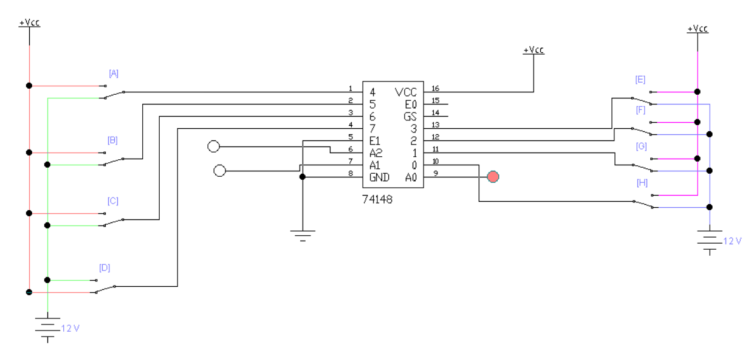

**Decoder**

A decoder does the opposite of an encoder.

It takes **n-bit binary input and converts it into 2ⁿ outputs.**

**Example: 3*-to-8 Decoder***

A binary-to-decimal decoder takes binary 0101 and activates only output line 5.

Used in devices like 7-segment displays (to show numbers on digital clocks/calculators).

TV remote signal (binary) → decoded into commands (volume up, channel change).

**Purpose:** Expand coded input into its original unique output.

**Truth Table:**

| **C** | **B** |  |  | **A** | **Y7 Y6 Y5 Y4 Y3 Y2 Y1 Y0** |
| --- | --- | --- | --- | --- | --- |
| 0 | 0 |  |  | 0 | 0 0 0 0 0 0 0 **1** |
| 0 | 0 |  |  | 1 | 0 0 0 0 0 0 **1**  0 |
| 0 | 1 |  |  | 0 | 0 0 0 0 0 **1**  0 0 |
| 0 | 1 |  |  | 1 | 0 0 0 0 **1**  0 0 0 |
| 1 | 0 |  |  | 0 | 0 0 0 **1**  0 0 0 0 |
| 1 | 0 |  |  | 1 | 0 0 **1**  0 0 0 0 0 |
| 1 | 1 |  |  | 0 | 0 **1**  0 0 0 0 0 0 |
| 1 | 1 |  |  | 1 | **1** 0 0 0 0 0 0 0 |

Output Expressions

Y0​​​=EB’A’

Y1=EB’A

Y2=EBA’

Y3=EBA​

**Decoder Diagram using EWB**

